DR. CUE CLASSIC “ARTISTIC POOL” TOUR

IN ASSOCIATION WITH…

DR. CUE PROMOTIONS, THE FOUNDATION OF R.A.C.K. AND ARTISTIC POOL PLAYING ARTISTS (APPA)

MASTER CHALLENGE PROGRAM

(ARTISTIC CUP EVENTS)

8 DISCIPLINES – 7 SHOTS / CHALLENGES EACH
(PLUS 2 TIEBREAKERS)

FOR PRELIMINARIES AND PLAYOFF MATCHES

ARTISTIC POOL DEFINITION AND DISCIPLINES

TEXT AND GRAPHIC PRESENTATIONS

EVENT / CHALLENGE RULES / REGULATIONS

PENALTIES / FORMAT / SCORING

PLAYER RESPONSIBILITIES / CONDUCT

Computer Services for Dr. Cue Classic “Artistic Pool” Tour Shots / Challenges

Provided By

Paul “Professor Q – Ball” Frankel

Dr. Cue Classic “Artistic Pool” Tour Shots / Challenges / Scoring Process

Selected By

Tom “Dr. Cue” Rossman

Cup Event Schedule / Special Features, Player / Event Dress/ Equipment Updates, Sport History, State Of The “Art”, RACK Room Amenities, Tour Sponsors, Plus League / “Cup” Results, And Much More Available In General Information Program

Dr. Cue Classic “Artistic” Cup Event Directors / Tour Administrators

Tom “Dr. Cue” and Marty “Ms. Cue” Rossman

drcue@artisticpool.org

765.795.4968 (home) / 765.760.7665 (cell)

AVAILABLE FOR ONLINE VIEWING AND DOWNLOAD ONLY

(Updated July 20, 2009)

PROGRAM PAGE GUIDE

Page 1 Front Cover – Program Title and General Inclusions

Page 2 Special Program Credits and Availability

Page 3 Page Guide for All Program Contents

Page 4 Player Responsibilities / Code of Conduct / Event Rules

Page 5 Shot Setup “Tapping” Penalties, plus Format and Scoring

Page 6 Artistic Pool Definition and Disciplines

Page 7 Shot / Challenge General Rules and Regulations

Pages 8 – 75 Disciplines – Text & Graphic Presentations

Page 76 Special Shot / Challenge Template – Player / Fan Usage

Page 77 Player Autographs / Special Messages

Page 78 Back Cover – Dr Cue Artistic Pool Tour Banner / Shooting Logo

Player Responsibility / Code of Conduct / Event Rules:

- Players are responsible for all information on format / diagram / text details in Master Challenge Program or as explained by event director / table judge
- Players in a respective table group that are in a non – shooting position
are responsible for judging correct setups and execution by the shooting player. Once a shot is taken it will be assumed to be correctly setup, and any subsequent score from a valid attempt make will be considered good

Note: The event director will handle questionable shot executions

- Players are responsible for the reading and understanding of all General Information Program contents and event schedule times for play, practice, and special sessions
- Players are responsible for posting accurate scores on event score sheets per the scoring process as explained at the players meeting and as detailed
under “scoring process / shooting readiness” section of this program
- Players are responsible for verifying scores posted by official scorekeeper
- Players may ask the table judge and / or the event director for clarification of any specific point of program(s) or event rules
- Players are also reminded of the dress requirements, rules of conduct, and special caution rule for “tapping” balls in place as explained in program(s)
- Players must exhibit good sportsmanship, demeanor, and image during event or risk loss of entry fee and any prize fund payment due
- Players must complete program or they forfeit entry fee and prize money
- No doctoring of, or tampering with any venue equipment

1) No Warning Category – Loss of entry fee and any prize money due

a) No gambling (at any time)
b) No drugs (at any time)
c) No intoxication to excess (at any time) – by review

2) One Warning Category – Subject to review & penalty (points deduction, etc.)

a) No smoking or chewing tobacco during competitive matches and per
venue restrictions
b) No intoxicants during competition (actual matches)
c) No unsportsmanlike conduct or sharking
d) No foul or indiscriminate language

Note: Event director may remove any player from competition for violations.

Special Notice on Shot Setups for All Events:

Player “Tapping” Caution Rule: Care should be taken with the “setting into position” of any object ball(s) and/or cue ball(s) by each player! A gentle “tapping” is allowed only!! The table judge, official scorekeeper, or event director will caution the offending player of hard and / or hammering hits to ball placements, and remind them to have concern and consideration for other players that follow and their setup efforts. The official score keeper will register point penalties against respective discipline scores of the offending player for repeat abuse of this rule as follows:

a) 1st Warning – No penalty
b) 2nd Warning – 1 point deduction from discipline score
c) 3rd Warning – 3 point deduction from discipline score
d) 4th Warning – 5 point deduction from discipline score
e) 5th Warning – Disqualification (Forfeit of entry fee and prize money)

Format (Preliminaries + Playoff Matches) / Positions of Finish:

The total score registered after all 40 program challenges are completed by each player will determine the overall position of finish prior to any playoff rounds, as well as the respective discipline champions. The initial factors for breaking ties will be 1st, 2nd, 3rd attempt make totals and then the respective point values for them. There are two tiebreaker shots / challenges in the Master Challenge Program, which will be used if designated overall positions of finish and respective discipline champions are not determined by the other tiebreaker factors.

We have modified the selection options for the 40 prelim shots / challenges starting in 2009. In each discipline there will be 1 – 4 point value challenge, 1 – 5, 1 – 6, 2 – 7’s (a or b choice), and 2 – 8’s (a or b choice). The 5 challenges actually attempted in each of the 8 disciplines offer a maximum point total possible of 30 with “perfect value makes” scored.

Special Playoff Notes:

We have also added match play format to the final day of competition starting in 2009. The top 12 scoring players from the 1st 2 days of competition (8 disciplines) will play in a single elimination shootout on Sunday (after the RACK Room fellowship service is over – see event schedule in General Information Program).

The top 4 scoring players from the prelims will receive a 1st round bye. Each round match will consist of 10 total challenges pre-selected by Dr. Cue from the 56 preliminary challenges listed in the Master Challenge Program. All players in a given round will shoot the same 10 shots. The 10 challenge selections will vary from round to round. The playoff challenges selected for each round will be released a minimum of 60 days prior to the event.

Scoring Process / Shooting Readiness:

Each player will register points on their own score sheet in coordination with scores posted by an official scorekeeper. Player and scorekeeper will verify that both scores posted are the same. If disputed, it will be resolved at once. Non – shooting “group” players will be asked for input if needed, and subsequent dispute settlement will be done by event director. After each round the scorekeeper will initial all score sheets. The event director will then verify all discipline and / or cumulative score totals for arena display. Players should be ready when it is their turn to shoot, and they should make every effort to avoid unnecessary playing delays.
Artistic Pool Definitions & Disciplines

“Artistic” by dictionary definition means beauty, skillfully, and tastefully done, aesthetically pleasing…relating to or characteristic of one who is skilled in public performance, or one who
exhibits artistry or skill in his or her work. Art is a skill or “knack”.

“Artistic Pool” is the umbrella word for these skills and / or “knacks”.

There are 8 disciplines of “Artistic Pool”. These follow…with an explanation for each:

Discipline 1 – Trick and / or Fancy

This primarily deals with setup shots, multiple ball configurations, and / or a shot where the cue ball travels in a “kick” pattern to make a final ball(s). It may also include “extreme” cut shots and special skill shots not in other disciplines.

Discipline 2 – “Prop” / “Novelty” / Special Arts

Unusual or new shots of any nature, shots with “props”, such as cues, bridge(s), rack(s), coin(s), chalk, etc., and shots of a unique or “special” art form, such as wing shots, time shots, “legal” or “illegal” follow-thru shots, push shots, roller coaster technique / waterfall specialties, plus demonstrations of one-handed “jack up” shooting, behind the back, under the leg, and more. It is often referred to as the “general amusement” category.

Discipline 3 – Draw

Basic to advanced with cue ball greater than ½ inch from 1st object ball.

Discipline 4 – Follow

Basic to advanced with cue ball greater than ½ inch from 1st object ball.

Discipline 5 – Bank / Kick

“Bank” meaning to hit object ball(s) into cushion(s), and “kick” meaning to hit cue ball into
“x” number of cushions first and then into object ball(s), etc.

Discipline 6 – “Stroke”

Cue ball less than ½ inch from 1st object ball, for draw or follow, plus accuracy position shots, speed control shots, or unique “stroke” shots.

Discipline 7 – Jump

Any shot utilizing “jump” technique, other than “prop” shots with bridge(s), and some special “stroke” shots.

Discipline 8 – Masse

Level, Half, and Full masse – Cue elevations over 10 degrees and select “draw” (curve) shots

Shot / Challenge General Setup Rules / Regulations

1) The table judge or event director has the final approval on all setups. The player may ask
questions at any time on respective shot / challenge setup text and / or diagram details.

2) The table judge or non shooting players in a player group will help place all props or the
various “obstacles” and/or “obstacle rows” required in some of the shots / challenges.

3) The player has control of placement and / or adjustment for all ball in hand placements of
cue ball (s) and / or object ball(s) per diagram explanations.

4) The player has control of placement and / or adjustment for all setups of balls placed for
allowance of throw effect between balls to respective designated pockets.

5) Legal cue ball in hand placement in a zone area or behind an “X” or designated line is
determined by the vertical edge of cue ball (must be completely in the zone). Any shot / challenge with a target zone or position of finish is judged by leading and/or trailing edge.

6) Object ball(s) which are placed “at or near” pocket(s) may be placed anywhere “at or near”
pocket(s) of designation, unless specified otherwise in diagram details.

7) Unless otherwise stated, cue ball scratch or miscue does not cancel a successful
completion of the shot / challenge.

8) At no time may any balls (cue ball or object ball) fly off the table. Penalty: No score for
that attempt.

9) Unless otherwise stated, the cue ball may always contact an extra cushion(s) near an
object ball(s) positioned by a respective pocket

10) Players are free to shoot any shot / challenge from either side of the table, as well as
shooting the “mirror image” of the shot / challenge. The intent of the challenge must be maintained in all setups / executions. Decision of the event director / table judge is final.

11) Accidental nudging of cue ball is not considered a stroke or attempt of shot – player is
allowed to shoot attempt again.

Legend for Table Diagrams:
Cue ball(s) – Circle with “c” inside it or open circle
Object ball(s) – Circle with wide dark line inside it
Very wide / thin solid line(s) – Cue ball(s) travel
Medium wide solid line(s) – Object ball(s) travel

Object ball(s) letters (A, B, C, D, E, and F) – Designated pocket(s) of make
Object ball(s) letters (X, Y, Z, or as noted) – Auxiliary balls for specific shot purposes

Special Note: Travel lines are suggested paths only – Different table conditions may require adjustments on part of player!!

DISCIPLINE
1

TRICK AND FANCY
SHOTS

Discipline: Trick and Fancy Shots Shot / Challenge #1

Degree of Difficulty: 4.0

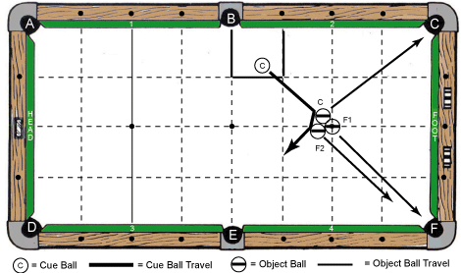

Cue Ball(s) Placement:

In hand – anywhere in marked box zone

Object Ball(s) Placement:

“F1” ball on foot spot, “C” ball and “F2” ball frozen to each other, and both balls frozen to “F1” ball

Objective:

Shoot cue ball to “C” ball. Then, cue ball caroms to “F2” ball. Make 3 object balls as pocket letters designate.

Special Notes: None

Scoring:

- Attempt #1 – 4 points
- Attempt #2 – 3 points
- Attempt #3 – 2 points

Discipline: Trick and Fancy Shots Shot / Challenge #2

Degree of Difficulty: 5.0

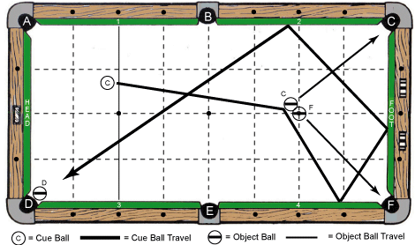
Cue Ball(s) Placement:

In hand – anywhere behind head string line

Object Ball(s) Placement:

“F” ball on foot spot, “C” ball frozen to “F” ball and “D” ball at or near pocket “D”
Objective:

Shoot cue ball to “C” ball. Then, cue ball travels at least 3 cushions around table to “D” ball. Make 3 object balls as pocket letters designate.

Special Notes: None

Scoring:

- Attempt #1 – 5 points
- Attempt #2 – 4 points
- Attempt #3 – 3 points

Discipline: Trick and Fancy Shots Shot / Challenge #3

Degree of Difficulty: 6.0

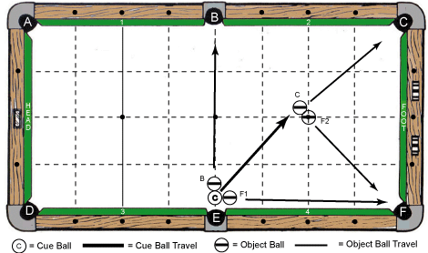
Cue Ball(s) Placement:

In hand (within 1 ball’s width of pocket “E”) – frozen to “B” ball and “F1” ball

Object Ball(s) Placement:

“F2” ball on foot spot, “C” ball frozen to “F2” ball, “B” ball and “F1” ball frozen to cue ball as diagram indicates

Objective:

Shoot cue ball into “B” ball and “F1” ball. Then, cue ball will contact “C” ball. Make 4 object balls as pocket letters designate.

Special Notes: None

Scoring:

- Attempt #1 – 6 points
- Attempt #2 – 5 points
- Attempt #3 – 4 points

Discipline: Trick and Fancy Shots Shot / Challenge #4A

Degree of Difficulty: 7.0

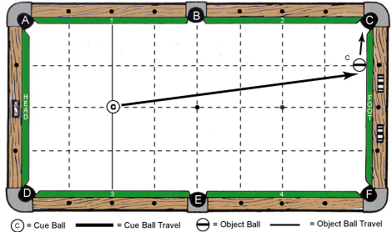

Cue Ball(s) Placement:

Centered on head spot of table

Object Ball(s) Placement:

“C” ball frozen to foot cushion and centered at one diamond from pocket “C”

Objective:

Shoot cue ball to “C” ball and make “C” ball as pocket letter designates

Special Notes: None

Scoring:

- Attempt #1 – 7 points
- Attempt #2 – 6 points
- Attempt #3 – 5 points

Discipline: Trick and Fancy Shots Shot / Challenge #4B

Degree of Difficulty: 7.0

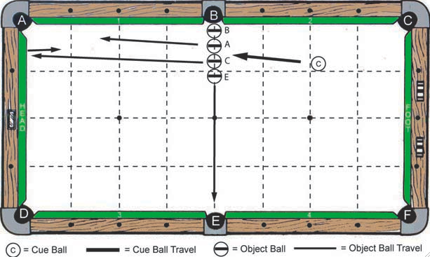

Cue Ball(s) Placement:

In hand

Object Ball(s) Placement:

“B” ball, “A” ball, “C” ball, and “E” ball in hand and frozen to each other near “B” pocket

Objective:

Shoot cue ball to “C” ball. Then, cue ball caroms to “A” ball. Make all object balls as pocket letters designate.

Special Notes: Cue ball may not hit “C” ball more than once

Scoring:

- Attempt #1 – 7 points
- Attempt #2 – 6 points
- Attempt #3 – 5 points

Discipline: Trick and Fancy Shots Shot / Challenge #5A

Degree of Difficulty: 8.0

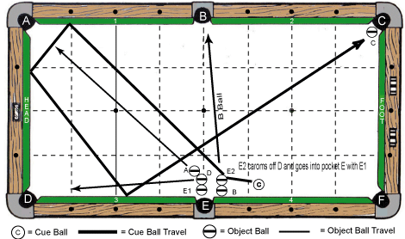

Cue Ball(s) Placement:

In hand

Object Ball(s) Placement:

“B” ball and “E2” ball in hand and frozen to each other with “B” ball frozen to cushion #4. “A”, “D”, and “E1” balls in hand and all are frozen to each other. “C” ball is at or near pocket “C”.

Objective:

Shoot cue ball to “E2” ball. Then, cue ball travels at least 3 cushions around table to “C” ball. Make all object balls as pocket letters designate.

Special Notes: None

Scoring:

- Attempt #1 – 8 points
- Attempt #2 – 7 points
- Attempt #3 – 6 points

Discipline: Trick and Fancy Shots Shot / Challenge #5B

Degree of Difficulty: 8.0

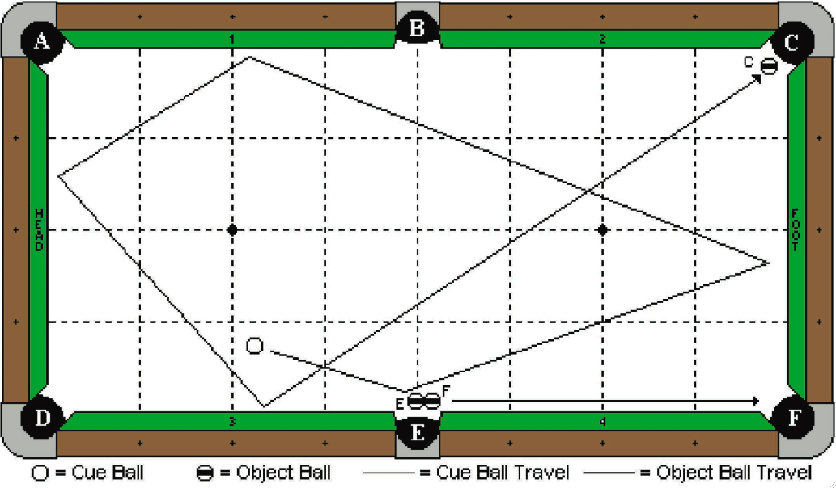

Cue Ball(s) Placement:

In hand

Object Ball(s) Placement:

“E” and “F” balls are as diagrammed and adjustable. “C” ball is at or near pocket “C”.

Objective:

Shoot the cue ball and make “E” ball in pocket “E”, and “F” ball in pocket “F”. The cue ball will travel 4 cushions as diagrammed and make “C” ball.

Special Notes: Cue ball must be at least 1 chalk’s width from “E” ball

Scoring:

- Attempt #1 – 8 points
- Attempt #2 – 7 points
- Attempt #3 – 6 points

DISCIPLINE
2

PROP NOVELTY
SPECIAL ARTS

Discipline: Prop / Novelty / Special Arts Shot / Challenge #1

Degree of Difficulty: 4.0

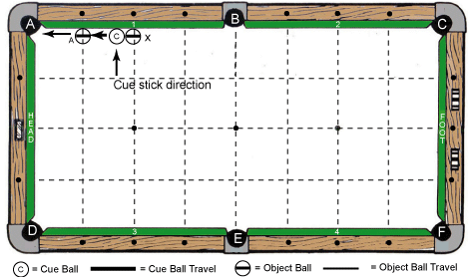
Cue Ball(s) Placement:

Frozen to both cushion #1 and “X” ball

Object Ball(s) Placement:

“X” ball frozen to cushion #1 and at center diamond between pocket “B” and pocket “A”, “A” ball frozen to cushion #1 and centered at one diamond from pocket “A”

Objective:

Shoot (push) cue ball into cushion #1. Cue ball will move “X” ball and then carom to “A” ball. Make “A” ball as pocket letter designates.

Special Notes: “X” ball must move for challenge to score, assuming “A” ball is made

Scoring:

- Attempt #1 – 4 points
- Attempt #2 – 3 points
- Attempt #3 – 2 points

Discipline: Prop / Novelty / Special Arts Shot / Challenge #2

Degree of Difficulty: 5.0

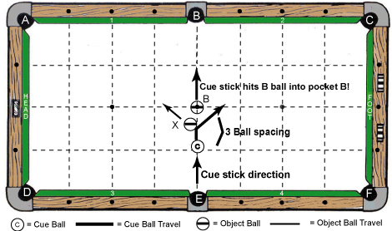
Cue Ball(s) Placement:

Centered on B – E line and exactly 3 ball spacing from “B” ball
Object Ball(s) Placement:

“B” ball centered on center spot of table, “X” ball is placed so that edge is flush with B – E line and positioned half way between cue ball and “B” ball

Objective:

Shoot cue ball straight toward “B” ball. Cue ball will hit half of “X” ball and deflect “out of way” as diagram indicates. Cue stick continues follow thru in one fluent motion, so that tip contacts “B” ball and makes it in pocket “B”

Special Notes: Hesitation on final stroke “forward” movement cancels any attempt score.

Scoring:

- Attempt #1 – 5 points
- Attempt #2 – 4 points
- Attempt #3 – 3 points

Discipline: Prop / Novelty / Special Arts Shot / Challenge #3

Degree of Difficulty: 6.0

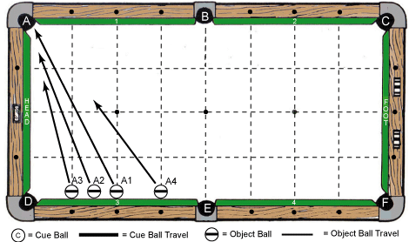

Cue Ball(s) Placement: None

Object Ball(s) Placement:

“A1”, “A2”, “A3”, and “A4” balls are frozen to cushion #3, “A4” ball is at 1st diamond to left of pocket “E”, “A1” ball is centered at middle diamond, “A2” ball is one ball spacing to left of “A1” ball, “A3” ball is one ball spacing to left of “A2” ball.

Objective:

Shoot “A4” ball first toward pocket “A”. While it is moving, shift body position and shoot “A1”, “A2” and “A3” balls in order toward pocket “A”. All 4 balls are made in pocket “A”
with “A1” ball going in first, “A2” ball second, “A3” ball third, and “A4” ball going in last.

Special Notes: Balls may contact each other while moving (numerical sequence best for balls)

Scoring:

- Attempt #1 – 6 points
- Attempt #2 – 5 points
- Attempt #3 – 4 points

Discipline: Prop / Novelty / Special Arts Shot / Challenge #4A

Degree of Difficulty: 7.0

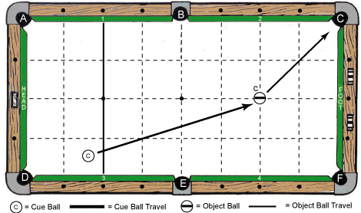

Cue Ball(s) Placement:

In hand – anywhere behind head string line

Object Ball(s) Placement:

“C” ball centered on foot spot of table

Objective:

Shoot cue ball to “C” ball one handed. Make “C” ball as pocket letter designates

Special Notes:

Player may use table rail or corner pocket to rest cue on while shooting, but may not use “groove” created by pocket / rail as cue guide. Bridge hand may not touch cue during stroke!

Scoring:

- Attempt #1 – 7 points
- Attempt #2 – 6 points
- Attempt #3 – 5 points

Discipline: Prop / Novelty / Special Arts Shot / Challenge #4B

Degree of Difficulty: 7.0

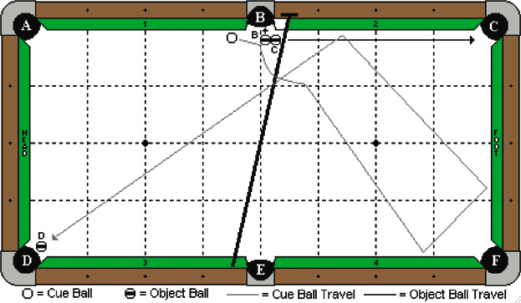

Cue Ball(s) Placement:

In hand

Object Ball(s) Placement:

“B” and “C” balls are frozen near pocket “B” and adjustable. “D” ball at or near pocket “D”. The bridge is on the rail tops, with the head of the bridge near pocket “B”. The player has the option to prop up the butt end of the bridge with a chalk cube.

Objective:

Shoot the cue ball into “B” ball. “B” and “C” balls will go as pocket letter designates. The cue ball will jump over the bridge, travel three cushions as diagrammed, and make “D” ball.

Special Notes:

The cue ball may hit the bridge.

Scoring:

- Attempt #1 – 7 points
- Attempt #2 – 6 points
- Attempt #3 – 5 points

Discipline: Prop / Novelty / Special Arts Shot / Challenge #5A

Special Scoring: 2 points per shot made (maximum 8 total points)

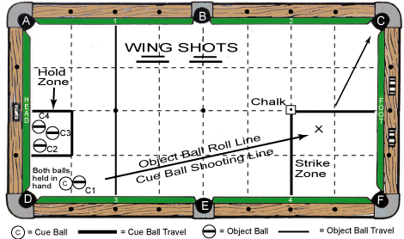
Cue Ball(s) Placement:

In hand – anywhere behind head string line. Cue ball must start in hand of shooter and may be placed on table only “after” object ball is released.

Object Ball(s) Placement:

Each “C” ball starts in shooter’s hand with cue ball. Note: Chalk is placed on foot spot of table.

Objective:

Hold cue ball and “C1” ball in hand, roll “C1” ball down table, and position cue ball after “C1” ball is released. Shoot cue ball into “rolling” “C1” ball in “strike zone” and make “C1” ball in pocket “C”. Repeat process with “C2”, “C3”, and “C4” being held in “hold zone”.

Special Notes:

One attempt per wing shot. No abort rolls are allowed. If chalk is touched by object ball – no score on that roll. Each “C” ball must be rolling when cue ball contacts it. If a “C” ball stops rolling before cue ball makes contact, no score on that roll. No guides are allowed when rolling object balls or in positioning of cue ball.

Scoring: 2 points per shot made – maximum 8 total points, if all 4 “wing shots” successful

Discipline: Prop / Novelty / Special Arts Shot / Challenge #5B

Special Scoring: 2 points per shot made (maximum 8 total points)

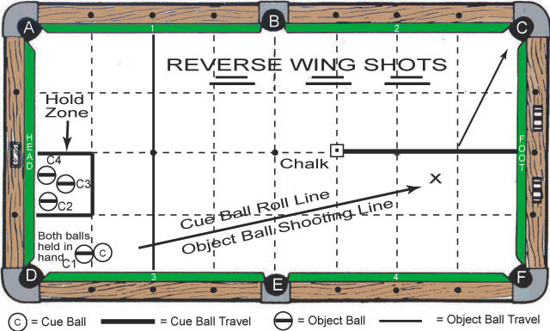

Cue Ball(s) Placement:

In hand – anywhere behind head string line. Cue ball must start in hand of shooter

Object Ball(s) Placement:

Each “C” ball starts in shooter’s hand with cue ball and may be placed on table only “after” the cue ball is released. Note: Chalk is placed on long centerline and 3 segments from foot cushion.

Objective:

Hold cue ball and “C1” ball in hand; roll cue ball down table past chalk, and position “C1” ball after cue ball is released. Shoot “C1” ball into “rolling” cue ball as diagram suggests and “carom” make “C1” ball in pocket “C”. Repeat process with “C2”, “C3”, and “C4” being held in “hold zone”.

Special Notes:

One attempt per wing shot. No abort rolls are allowed. If chalk is touched by cue ball on initial roll or by object ball – no score on that roll. Cue ball must be rolling when each object ball contacts it. If the cue ball stops rolling before the object ball makes contact, no score on that roll. No guides are allowed when rolling the cue ball or in positioning of the object balls.

Scoring: 2 points per shot made – maximum 8 total points, if all 4 “wing shots” successful

DISCIPLINE
3

DRAW
SHOTS

Discipline: Draw Shots Shot / Challenge #1

Degree of Difficulty: 4.0

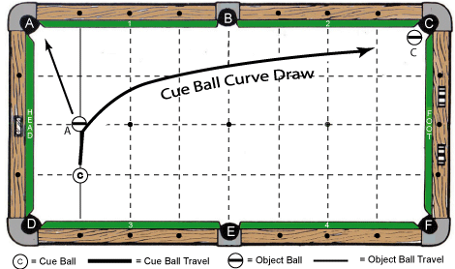

Cue Ball(s) Placement:

Centered on 1 – 1 diamond point (1 diamond segment off head cushion and cushion #3)

Object Ball(s) Placement:

“A” ball centered on long center line of table and one diamond segment off head cushion, “C” ball at or near pocket “C”

Objective:

Shoot cue ball into “A” ball and draw to “C” ball. “A” ball and “C” ball are made as pocket letters designate.

Special Notes: None

Scoring:

- Attempt #1 – 4 points
- Attempt #2 – 3 points
- Attempt #3 – 2 points

Discipline: Draw Shots Shot / Challenge #2

Degree of Difficulty: 5.0

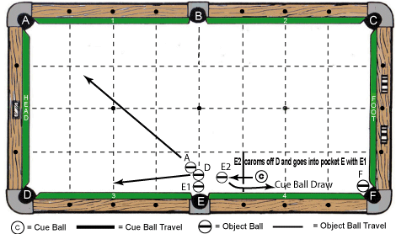
Cue Ball(s) Placement:

In hand – anywhere behind dark line one diamond segment to right of pocket “E”

Object Ball(s) Placement:

“E2” ball is in hand and one ball spacing off cushion #4, “A”, “D”, and “E1” balls are in hand and all are frozen to each other, “F” ball is at or near pocket “F”.

Objective:

Shoot cue ball into “E2” ball. Then, cue ball draws to “F” ball. Make all object balls as pocket letters designate.

Special Notes: None

Scoring:

- Attempt #1 – 5 points
- Attempt #2 – 4 points
- Attempt #3 – 3 points

Discipline: Draw Shots Shot / Challenge #3

Degree of Difficulty: 6.0

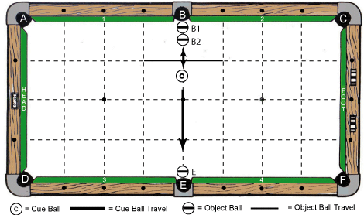
Cue Ball(s) Placement:

In hand – anywhere centered on B – E line and behind the dark line 1 diamond segment from the top cushions of the table

Object Ball(s) Placement:

“B1” ball centered on B – E line and back vertical edge of ball even with slate cut, “B2” ball is centered on B – E line and frozen to “B1” ball. “E” ball centered on B – E line and back vertical edge of ball even with slate cut

Objective:

Shoot cue ball to “B2” ball. Then, cue ball draws to “E” ball. Make 3 object balls as pocket letters designate

Special Notes: None

Scoring:

- Attempt #1 – 6 points
- Attempt #2 – 5 points
- Attempt #3 – 4 points

Discipline: Draw Shots Shot / Challenge #4A

Degree of Difficulty: 6.0 + Bonus

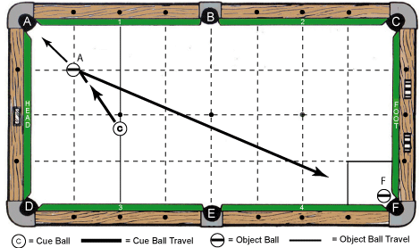
Cue Ball(s) Placement:

In hand – anywhere centered on head string line of table

Object Ball(s) Placement:

“A” ball centered on 1 – 1 diamond point (1 diamond segment off head cushion and cushion #1), “F” ball at or near pocket “F”

Objective:

Shoot cue ball to “A” ball and make it in pocket “A”. Draw cue ball to finish in marked 1 – 1 diamond zone near pocket “F”. If “F” ball is made by cue ball on the 1st attempt only, a bonus point is awarded, and the shot is considered complete as done.
Special Notes: Cue ball may scratch or leave zone if “F” ball is made on 1st attempt only!

Scoring:

- Attempt #1 – 6 points + 1 point bonus, if “F” ball is made
- Attempt #2 – 5 points
- Attempt #3 – 4 points
Scoring Note: Once score is made, shot is complete!

Discipline: Draw Shots Shot / Challenge #4B

Degree of Difficulty: 7.0

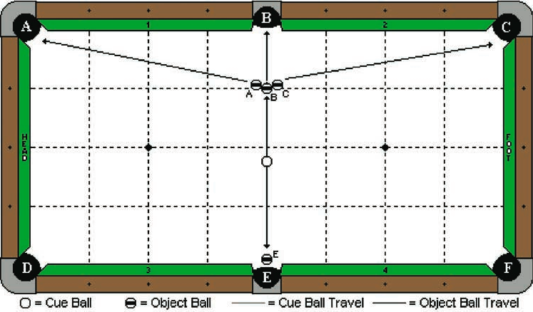

Cue Ball(s) Placement:

In hand behind the long centerline of the table

Object Ball(s) Placement:

“B” ball is on the centerline and 1 diamond segment from pocket “B”. “A” and “C” balls are frozen to “B” ball and adjustable. “E” ball is at or near pocket “E”.

Objective:

Shoot the cue ball to “B” ball. The cluster of 3 balls will go as pocket letter designates. The cue ball will draw back and make “E” ball.

Special Notes: None

Scoring:

- Attempt #1 – 7 points
- Attempt #2 – 6 points
- Attempt #3 – 5 points

Discipline: Draw Shots Shot / Challenge #5A

Degree of Difficulty: 8.0

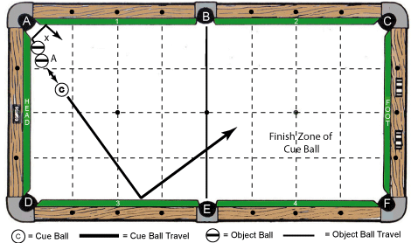

Cue Ball(s) Placement:

In hand

Object Ball(s) Placement:

“X” ball is exactly 2 ball’s spacing distance from edge of pocket “A”, “A” ball is in hand and frozen to “X” ball

Objective:

Shoot cue ball to “A” ball. Cue ball will draw to cushion #3 and into finish zone to right of B – E line. “X” ball banks 2 cushions away from pocket “A”. “A” ball made in pocket “A”.

Special Notes: Cue ball may not scratch and “X” ball does not have to be made

Scoring:

- Attempt #1 – 8 points
- Attempt #2 – 7 points
- Attempt #3 – 6 points

Discipline: Draw Shots Shot / Challenge #5B

Degree of Difficulty: 7.0 + Bonus

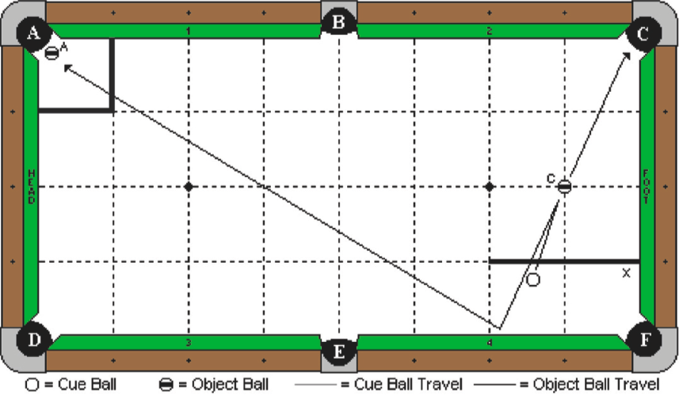

Cue Ball(s) Placement:

In hand behind “X” line

Object Ball(s) Placement:

“C” ball is on the diamond intersection line as diagrammed. “A” ball is at or near pocket “A”

Objective:

Shoot cue ball to “C” ball and make it in pocket “C”. Draw cue ball to finish in marked 1 – 1 diamond zone near pocket “A”. If “A” ball is made by cue ball on the 1st attempt only, a bonus point is awarded, and the shot is considered complete as done.
Special Notes: Cue ball may scratch or leave zone if “A” ball is made on 1st attempt only!

Scoring:

- Attempt #1 – 7 points + 1 point bonus, if “A” ball is made
- Attempt #2 – 6 points
- Attempt #3 – 5 points
Scoring Note: Once score is made, shot is complete!

DISCIPLINE
4

FOLLOW
SHOTS

Discipline: Follow Shots Shot / Challenge #1

Degree of Difficulty: 4.0

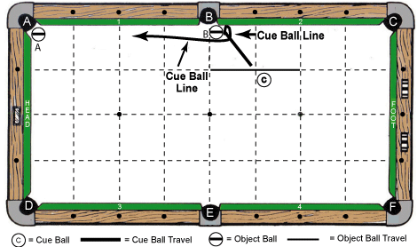
Cue Ball(s) Placement:

In hand – anywhere behind the dark line 1 diamond segment from the top cushions of the table

Object Ball(s) Placement:

“B” ball in hand near point of pocket “B”, “A” ball at or near pocket “A”

Objective:

Shoot cue ball to “B” ball, carom to cushion #2, then rebound and curve back to “A” ball. Make both object balls as pocket letters designate.

Special Notes: None

Scoring:

- Attempt #1 – 4 points
- Attempt #2 – 3 points
- Attempt #3 – 2 points

Discipline: Follow Shots Shot / Challenge #2

Degree of Difficulty: 5.0

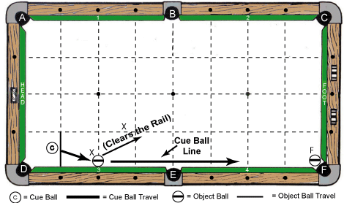

Cue Ball(s) Placement:

In hand – anywhere behind dark line 1 diamond segment to right of pocket “D”

Object Ball(s) Placement:

“X” ball frozen to cushion #3 and centered at middle diamond, “F” ball at or near pocket “F”

Objective:

Shoot cue ball to “X” ball, which will clear cushion. Then, cue ball will follow to make “F” ball in pocket “F”.

Special Notes: “X” ball does not have to be made

Scoring:

- Attempt #1 – 5 points
- Attempt #2 – 4 points
- Attempt #3 – 3 points

Discipline: Follow Shots Shot / Challenge #3

Degree of Difficulty: 6.0

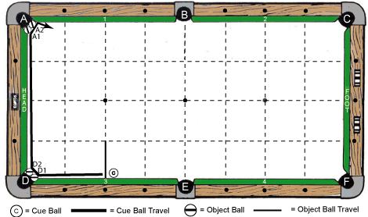

Cue Ball(s) Placement:

In hand – anywhere behind dark line 2 diamond segments to right of pocket “D”

Object Ball(s) Placement:

“D1” and “D2” balls are in hand at or near pocket “D”, “A1” and “A2” balls are in hand at or near pocket “A”

Objective:

Shoot cue ball to “D1” ball and carom to “D2” ball. Then, cue ball travels along head cushion to contact “A1” ball and carom to “A2” ball. Make all 4 object balls as pocket letters designate.

Special Notes: None

Scoring:

- Attempt #1 – 6 points
- Attempt #2 – 5 points
- Attempt #3 – 4 points

Discipline: Follow Shots Shot / Challenge #4A

Degree of Difficulty: 7.0

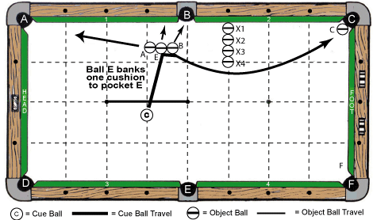

Cue Ball(s) Placement:

In hand – anywhere behind dark line shown on center long line of table

Object Ball(s) Placement:

“B” ball and “E” ball are each 2 ball’s spacing distance from cushion #1; “E” ball is frozen to “B” ball, “A” ball is frozen to “E” ball. “B”, “E”, and “A” balls are in hand (2 ball spacing must be maintained for “B” and “E” balls), “C” ball at or near pocket “C”, blocking balls “X1” thru “X4” are frozen to each other 1 diamond right of B – E line, “X1” ball is frozen to cushion #2

Objective:

Shoot cue ball to “E” ball, carom to “B” ball, and curve around blocking balls to “C” ball. Make “B” ball, “E” ball, “A” ball, and “C” ball as pocket letters designate.

Special Notes: Blocking balls may not be touched until “C” ball is made

Scoring:

- Attempt #1 – 7 points
- Attempt #2 – 6 points
- Attempt #3 – 5 points

Discipline: Follow Shots Shot / Challenge #4B

Degree of Difficulty: 7.0

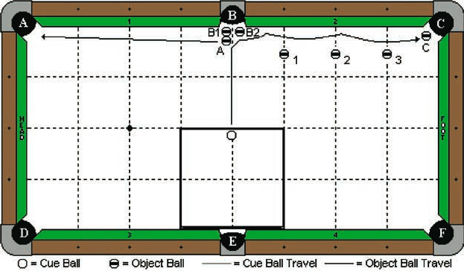

Cue Ball(s) Placement:

In hand – anywhere within the indicated square zone

Object Ball(s) Placement:

“A”, “B1”, and “B2” balls are as diagrammed and adjustable near pocket “B”. “C” ball is at or near pocket “C”. Three blocker balls are on the diamond lines as diagrammed, and exactly 2 ball’s width from cushion 2.

Objective:

Shoot the cue ball into the “A” ball. The “B1” ball will go into pocket “B”. The “A” ball will go into pocket “A”. The cue ball will carom into the “B2” ball, making it in pocket “B”. The cue ball will then travel down the cushion and make the “C” ball in pocket “C”.

Special Notes: Blocking balls may not be touched until “C” ball is made

Scoring:

- Attempt #1 – 7 points
- Attempt #2 – 6 points
- Attempt #3 – 5 points

Discipline: Follow Shots Shot / Challenge #5A

Degree of Difficulty: 7.0 + Bonus

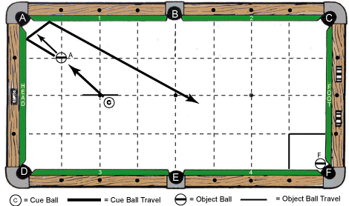

Cue Ball(s) Placement:

In hand – anywhere behind dark line shown on long center line of table

Object Ball(s) Placement:

“A” ball centered on 1 – 1 diamond point (1 diamond segment off head cushion and cushion #1), “F” ball at or near pocket “F”

Objective:

Shoot cue ball to “A” ball and make it in pocket “A”. Follow cue ball to finish in marked 1 – 1 diamond zone near pocket “F”. If “F” ball is made by cue ball on the 1st attempt only, a bonus point is awarded, and the shot is considered complete as done.
Special Notes: Cue ball may scratch or leave zone if “F” ball is made on 1st attempt only!

Scoring:

- Attempt #1 – 7 points + 1 point bonus, if “F” ball is made
- Attempt #2 – 6 points
- Attempt #3 – 5 points
Scoring Note: Once score is made, shot is complete!

Discipline: Follow Shots Shot / Challenge #5B

Degree of Difficulty: 8.0
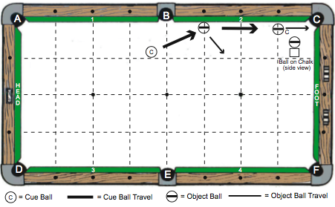

Cue Ball(s) Placement:

In hand – anywhere behind line (B – E)
Object Ball(s) Placement:

Solo object ball frozen to cushion #2 and one diamond to right of pocket “B”; Ball “C” is placed on top of a chalk cube. This ball/chalk unit is in hand near cushion 2 and 1 diamond left of pocket “C”.
Objective:

Shoot cue ball into 1st object ball to make it bank off cushion #2. Cue ball will follow to ball “C” on top of chalk, causing it to fall off chalk and make in pocket “C”. 1st object ball does not have to be made.
Special Notes:

Venue piece of chalk (new or old) may be used for this shot / challenge

Scoring:

- Attempt #1 – 8 points
- Attempt #2 – 7 points
- Attempt #3 – 6 points

DISCIPLINE
5

BANK / KICK
SHOTS

Discipline: Bank / Kick Shots Shot / Challenge #1

Degree of Difficulty: 4.0

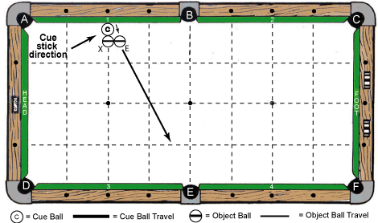

Cue Ball(s) Placement:

Frozen to cushion #1 and centered at middle diamond

Object Ball(s) Placement:

“X” ball frozen to cue ball and centered on head string line, “E” ball frozen to “X” ball and one ball spacing distance from cushion #1

Objective:

Shoot cue ball into cushion #1. Cue ball will compress cushion and “escape” from behind “X” ball. Then, cue ball will contact “E” ball and make it in pocket “E”.

Special Notes: “X” ball may not move by any means until after “E” ball is made

Scoring:

- Attempt #1 – 4 points
- Attempt #2 – 3 points
- Attempt #3 – 2 points

Discipline: Bank / Kick Shots Shot / Challenge #2

Degree of Difficulty: 4.0 + Bonus

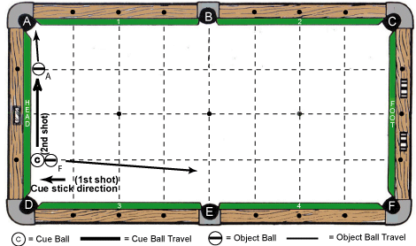

Cue Ball(s) Placement:

Frozen to head cushion and centered at 1st diamond from pocket “D”

Object Ball(s) Placement:

“F” ball in hand and frozen to cue ball, “A” ball frozen to head cushion and centered at 1st diamond from pocket “A”

Objective:

Shoot cue ball into head cushion and “kick” object ball “F” to make in pocket “F”. On attempt #1 only, shoot cue ball to “A” ball on a 2nd shot and make it in pocket “A” for a 1-point bonus.
Special Notes: Attempt #2 and #3 objective is to make “F” ball only in pocket “F”. “A” Ball may not move on any 1st shot taken to kick “F” ball in pocket “F”!!

Scoring:

- Attempt #1 – 4 points, plus 1 point bonus, if “A” ball is made on a 2nd shot
- Attempt #2 – 3 points
- Attempt #3 – 2 points
Scoring Note: Once score is made, shot is complete!

Discipline: Bank / Kick Shots Shot / Challenge #3

Degree of Difficulty: 6.0

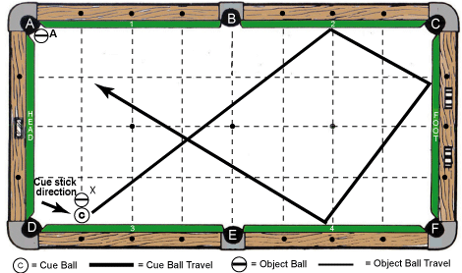
Cue Ball(s) Placement:

Frozen to cushion #3 and centered at 1st diamond from pocket “D”

Object Ball(s) Placement:

“X” ball frozen to cue ball and centered on line perpendicular to cue ball, “A” ball at or near pocket “A”

Objective:

Shoot cue ball into cushion #3. Cue ball will compress cushion and “escape” from behind “X” ball. Then, cue ball will travel at least 3 more cushions to make “A” ball in pocket “A”.

Special Notes: “X” ball may not move by any means until after “A” ball is made

Scoring:

- Attempt #1 – 6 points
- Attempt #2 – 5 points
- Attempt #3 – 4 points

Discipline: Bank / Kick Shots Shot / Challenge #4A

Degree of Difficulty: 7.0

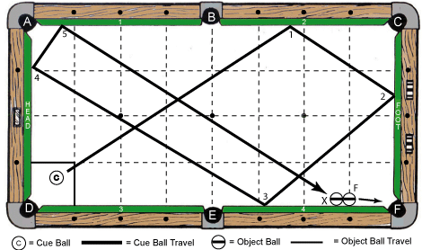

Cue Ball(s) Placement:

In hand – anywhere in marked box zone near pocket “D”
Object Ball(s) Placement:

“F” ball frozen to cushion #4 and 1 diamond from pocket “F”, “X” ball frozen to left side of “F” ball and also cushion #4

Objective:

Shoot cue ball at least 5 cushions around table per pattern in diagram. Then, cue ball will hit “X” ball / ”F” ball combination to make “F” ball in pocket “F”.

Special Notes: None

Scoring:

- Attempt #1 – 7 points
- Attempt #2 – 6 points
- Attempt #3 – 5 points

Discipline: Bank / Kick Shots Shot / Challenge #4B

Degree of Difficulty: 7.0

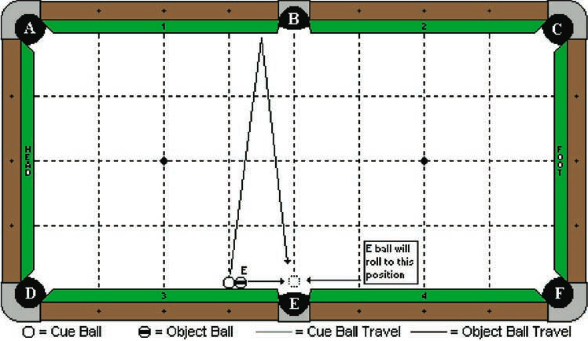

Cue Ball(s) Placement:

Frozen to the cushion at the 3rd diamond
Object Ball(s) Placement:

“E” ball frozen to the cushion and to the cue ball

Objective:

Shoot the cue ball to bank one rail as diagrammed. “E” ball will roll in front of pocket “E”. The cue ball will bank back into “E” ball and make it in pocket “E”.

Special Notes: None

Scoring:

- Attempt #1 – 7 points
- Attempt #2 – 6 points
- Attempt #3 – 5 points

Discipline: Bank / Kick Shots Shot / Challenge #5A

Special Scoring: 2 points per bank made (maximum 8 total points)

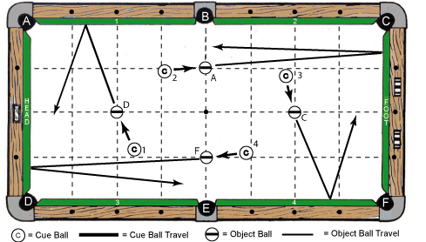

Cue Ball(s) Placement:

In hand – anywhere as assigned to make respective banks as noted in “objective” below

Object Ball(s) Placement:

“D” ball centered on head spot, “A” ball centered on B – E line and 1 diamond segment from top cushions on long line, “C” ball centered on foot spot, “F” ball centered on B – E line and 1 diamond segment from bottom cushions on long line.

Objective:

One attempt per bank! Shoot in clockwise or counter clockwise order (“C1” to “D” ball, “C2”
to “A” ball, “C3” to “C” ball, “C4” to “F” ball) or (“C1” to “D” ball, “C4” to “F” ball, “C3” to
“C” ball, “C2” to “A” ball. Make all 4 object balls as pocket letters designate.

Special Notes:

Once shooting has begun, players must continue rotation until 4 shots are complete.

Scoring:

2 points per bank made – maximum 8 total points, if all 4 “bank shots” successful

Discipline: Bank / Kick Shots Shot / Challenge #5B

Special Scoring: 2 points per bank made (maximum 8 total points)

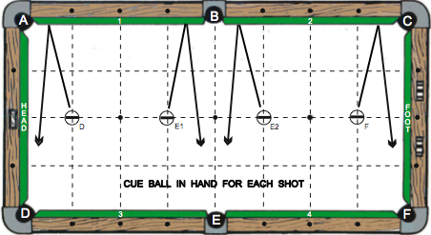

Cue Ball(s) Placement: In hand for each bank shot

Object Ball(s) Placement:

4 object balls are on “long line” of table from center of head cushion to center of foot cushion. “D” ball one diamond to right of head cushion; “E1” ball one diamond to left of line (B – E); “E2” ball one diamond to right of line (B – E); and “F” ball one diamond to left of foot cushion.

Objective:

Bank each object ball 1 cushion to respective pockets – make “D” ball in pocket “D”, make “E1” ball and “E2” ball in pocket “E”, and make “F” ball in pocket “F”. Cue ball must finish between long centerline of table and side cushions shooter is facing. Follow or draw stroke may be used.

Special Notes:

Shooter gets only one try per bank, plus shooter must stay on same side of table for all banks. Balls must be shot in order from left to right or from right to left – cross corner, cross side, cross side, and cross corner. No time limit! Shoot until all 4 banks attempted. Scratches not allowed!!

Scoring:

2 points per bank made – maximum 8 total points, if all 4 “bank shots” successful

DISCIPLINE
6

STROKE
SHOTS

Discipline: Stroke Shots Shot / Challenge #1

Degree of Difficulty: 4.0

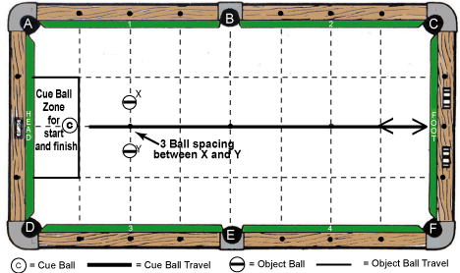
Cue Ball(s) Placement:

In hand – anywhere in marked cue ball start / finish zone as shown in diagram

Object Ball(s) Placement:

“X” ball and “Y” ball centered on head string line and equidistant on each side of long center line of table with 3 ball spacing between them

Objective:

Shoot cue ball from start / finish zone between “X” ball and “Y” ball to foot cushion. Rebound between “X” ball and “Y” ball to stop in start / finish zone for scoring success.

Special Notes: “X” ball and “Y” ball may not move by any means until after shot is complete

Scoring:

- Attempt #1 – 4 points
- Attempt #2 – 3 points
- Attempt #3 – 2 points

Discipline: Stroke Shots Shot / Challenge #2

Degree of Difficulty: 5.0

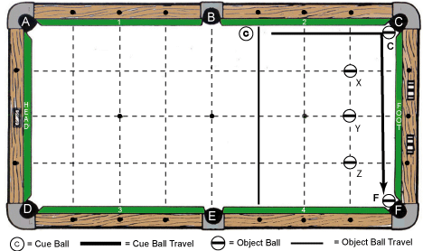
Cue Ball(s) Placement:

In hand – anywhere behind dark line 1 diamond segment to right of B – E line

Object Ball(s) Placement:

“C” ball and “F” ball placed between pocket center points and back edge of each should be flush
to slate cut of pockets “C” and “F” respectively, “X” ball, “Y” ball, and “Z” ball are on line which is 1 diamond segment from foot cushion and placed on 3 long lines as shown.

Objective:

Shoot cue ball to “C” ball with choice of stroke along foot cushion to contact “F” ball without hitting “X”, “Y”, or “Z” balls. “C” ball and “F” ball are made as pocket letters designate.

Special Notes: “X”, “Y”, and “Z” balls may not be moved by any means until shot is complete

Scoring:

- Attempt #1 – 5 points
- Attempt #2 – 4 points
- Attempt #3 – 3 points

Discipline: Stroke Shots Shot / Challenge #3

Degree of Difficulty: 6.0

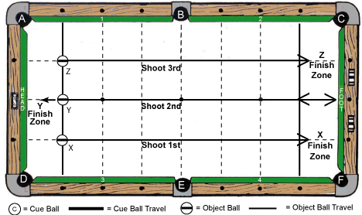
Cue Ball(s) Placement: Not applicable

Object Ball(s) Placement:

“X” ball, “Y” ball, and “Z” ball are on line which is 1 diamond segment from head cushion and placed on 3 long lines as shown.

Objective:

Shoot “X” ball 1st to “X” ball finish zone (approximately 1 table length), shoot “Y” ball 2nd to “Y” ball finish zone (approximately 2 table lengths), and shoot “Z” ball 3rd to “Z” ball finish zone (approximately 1 table length). Finish zones are 1 diamond segment wide off end cushions.

Special Notes: “Y” and “Z” balls must be shot before “X” ball stops – no collisions allowed

Scoring:

- Attempt #1 – 6 points
- Attempt #2 – 5 points
- Attempt #3 – 4 points

Discipline: Stroke Shots Shot / Challenge #4A

Degree of Difficulty: 7.0

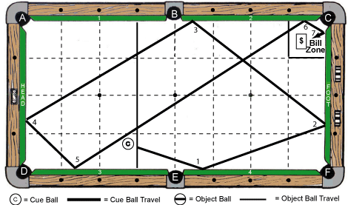
Cue Ball(s) Placement:

In hand – anywhere behind dark line 1 diamond segment to left of B – E line

Object Ball(s) Placement:

No object balls – Dollar bill is in hand, but must be completely inside “bill zone” near pocket “C” as diagram shows. Bill may be rotated as desired. (Dollar bill provided by event director)

Objective:

Shoot cue ball around table per 7-cushion diagram pattern. Cue ball must contact 7 cushions and land on dollar bill…determined by vertical edge of cue ball.

Special Notes: Player may move dollar bill from one attempt to another within “bill zone”

Scoring:

- Attempt #1 – 7 points
- Attempt #2 – 6 points
- Attempt #3 – 5 points

Discipline: Stroke Shots Shot / Challenge #4B

Degree of Difficulty: 7.0

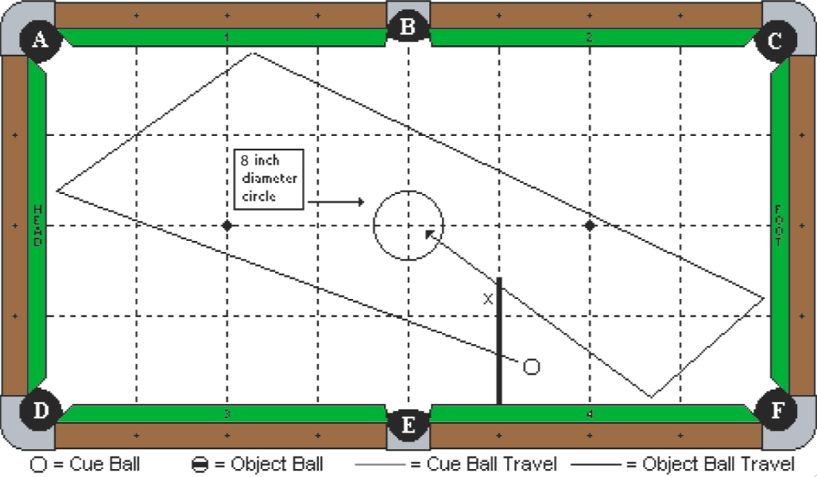

Cue Ball(s) Placement:

In hand behind the indicated line

Object Ball(s) Placement:

None. A circle is drawn centered on the table. The circle is exactly 8 inches in diameter.

Objective:

Shoot the cue ball 4 cushions as diagrammed and stop within the circle zone.

Special Notes: None

Scoring:

- Attempt #1 – 7 points
- Attempt #2 – 6 points
- Attempt #3 – 5 points

Discipline: Stroke Shots Shot / Challenge #5A

Degree of Difficulty: 8.0

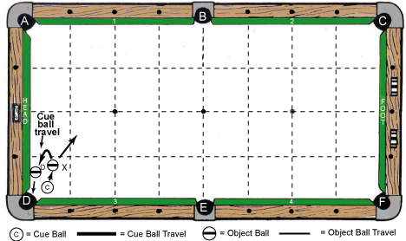

Cue Ball(s) Placement:

In hand – anywhere on table between “X” ball and cushion #3 / pocket “D”

Object Ball(s) Placement:

“D” ball frozen to head cushion and up to 3 ball spacing distance allowed from slate edge of pocket D, “X” ball in hand (approximately one half ball from “D” ball), edge of “X” ball closest to cushion #3 may not be past edge of “D” ball closest to cushion #1.

Objective:

Shoot cue ball into “X” ball and “stroke draw” to make “D” ball in pocket “D”

Special Notes: “X” ball does not have to be made – Multiple hits on “D” ball allowed

Scoring:

- Attempt #1 – 8 points
- Attempt #2 – 7 points
- Attempt #3 – 6 points

Discipline: Stroke Shots Shot / Challenge #5B

Degree of Difficulty: 7.0 + Bonus

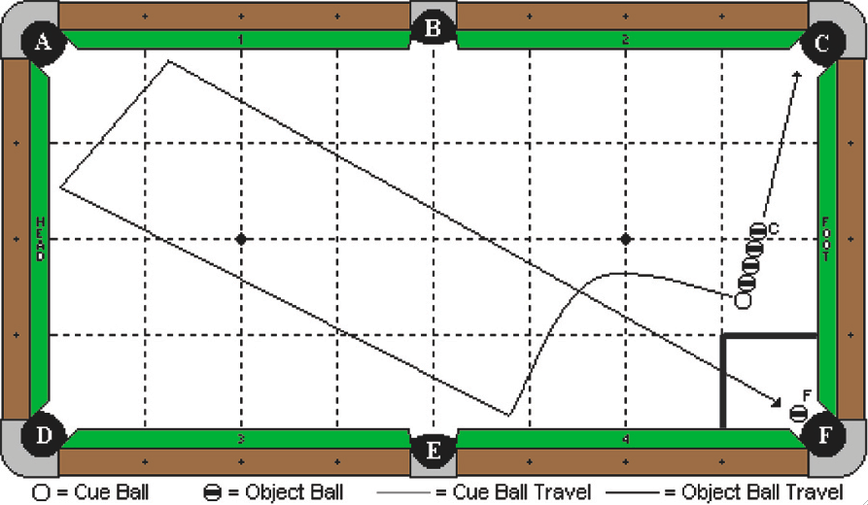

Cue Ball(s) Placement:

In hand, but no more than 2 diamonds away from the foot cushion

Object Ball(s) Placement:

4 balls are frozen in line and to the cue ball. None of the balls may be frozen to the foot cushion. “F” ball is at or near pocket “F”.

Objective:

Shoot the cue ball into the line of 4 balls. “C” ball must be made in pocket “C”. The cue ball will draw back and travel around table as diagrammed to finish in marked 1 – 1 diamond zone near pocket “F”. If “F” ball is made by cue ball on the 1st attempt only, a bonus point is awarded, and the shot is considered complete as done.
Special Notes: Cue ball may scratch or leave zone if “F” ball is made on 1st attempt only! The other 3 balls in the line do not need to be made, but cue ball may not contact them as it travels toward “F” ball. The cue ball may hit cushion 3 or 4 as the first cushion.

Scoring:

- Attempt #1 – 7 points + 1 point bonus, if “F” ball is made
- Attempt #2 – 6 points
- Attempt #3 – 5 points Scoring Note: Once score is made, shot is complete

DISCIPLINE
7

JUMP
SHOTS

Discipline: Jump Shots Shot / Challenge #1

Degree of Difficulty: 4.0

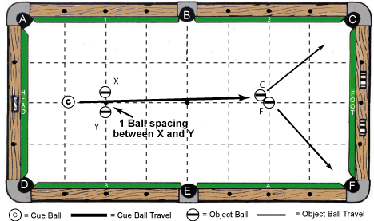

Cue Ball(s) Placement:

In hand – anywhere behind “X” and “Y” balls

Object Ball(s) Placement:

“X” ball and “Y” ball centered on head string line and equidistant on each side of long center line of table with exactly 1 ball spacing between them, “F” ball centered on foot spot, “C” ball frozen to “F” ball

Objective:

Shoot (jump) cue ball between “X” and “Y” balls to make “C” and “F” balls as pocket letters designate

Special Notes: “X” and “Y” balls may not move by any means until “C” and “F” balls are made

Scoring:

- Attempt #1 – 4 points
- Attempt #2 – 3 points
- Attempt #3 – 2 points

Discipline: Jump Shots Shot / Challenge #2

Degree of Difficulty: 5.0

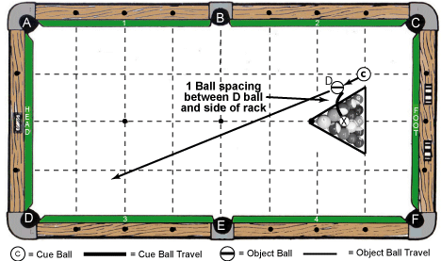

Cue Ball(s) Placement:

In hand – anywhere as required for execution of jump shot

Object Ball(s) Placement:

14 balls inside of rack (venue provided) with the middle ball in the 3rd row missing, “D” ball in hand outside of rack with 1 ball spacing distance to rack side. Rack is in normal position.

Objective:

Shoot cue ball into “D” ball with “jump” stroke. Cue ball must end up in the “missing ball” hole in the center of the rack when finished and the “D” ball must be made in pocket “D”.

Special Notes: None

Scoring:

- Attempt #1 – 5 points
- Attempt #2 – 4 points
- Attempt #3 – 3 points

Discipline: Jump Shots Shot / Challenge #3

Degree of Difficulty: 6.0

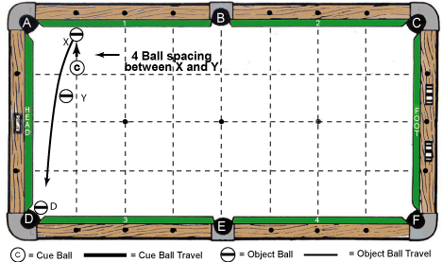
Cue Ball(s) Placement:

In hand – anywhere between “X” ball and “Y” ball
Object Ball(s) Placement:

“X” ball frozen to cushion #1 and centered at 1 diamond to right of pocket “A”, “Y” ball is a 4 ball spacing distance from “X” ball and positioned to block direct “on the table” kiss back of cue ball to “D” ball, “D” ball at or near pocket “D”

Objective:

Shoot cue ball into “X” ball with “jump” stroke and kiss back “over” the “Y” ball to make “D” ball in pocket “D”

Special Notes: “Y” ball may not move by any means until shot is complete

Scoring:

- Attempt #1 – 6 points
- Attempt #2 – 5 points
- Attempt #3 – 4 points

Discipline: Jump Shots Shot / Challenge #4A

Degree of Difficulty: 7.0

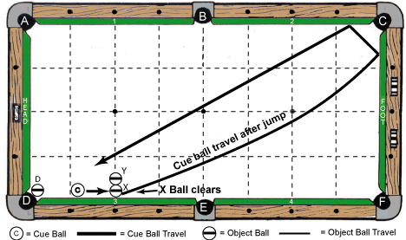

Cue Ball(s) Placement:

In hand – anywhere frozen to cushion #3

Object Ball(s) Placement:

“X” ball frozen to cushion #3 and centered on head string line, “Y” ball is frozen to “X” ball and also centered on head string line, “D” ball at or near pocket “D”

Objective:

Shoot (jump) cue ball into “X” ball, which will “escape” from its position. Cue ball will jump over “Y” ball and travel at least 2 cushions to make “D” ball in pocket “D”.

Special Notes: “Y” ball may not move until shot done, and “X” ball does not have to be made

Scoring:

- Attempt #1 – 7 points
- Attempt #2 – 6 points
- Attempt #3 – 5 points

Discipline: Jump Shots Shot / Challenge #4B

Degree of Difficulty: 7.0

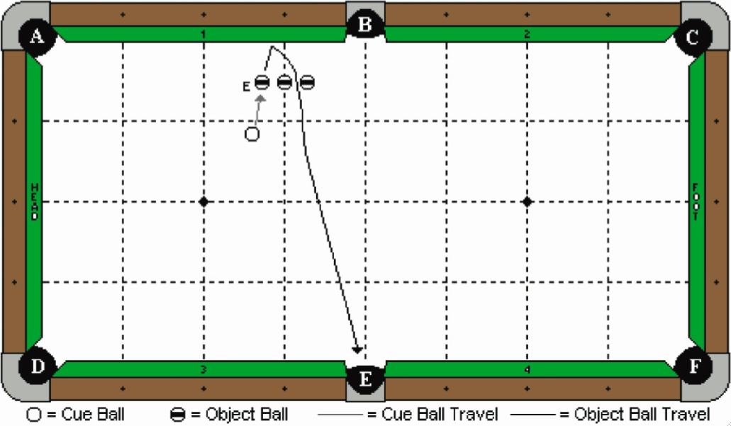

Cue Ball(s) Placement:

In hand

Object Ball(s) Placement:

Three object balls are in position as diagrammed. All balls are 2 ball’s width off the cushion, and the center ball is on the 3rd diamond line. All balls have a gap of 1 chalk’s width between them.

Objective:

Shoot the cue ball to “E” ball, causing it to hit the cushion and jump over the 2 blocking balls to make in pocket “E”.

Special Notes:

“E” ball may not contact the two balls to the right of it; however, the cue ball may hit them.

Scoring:

- Attempt #1 – 7 points
- Attempt #2 – 6 points
- Attempt #3 – 5 points

Discipline: Jump Shots Shot / Challenge #5A

Degree of Difficulty: 8.0

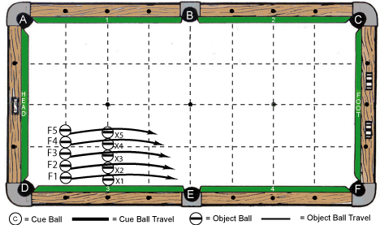

Cue Ball(s) Placement:

Not applicable

Object Ball(s) Placement:

“X1” thru “X5” balls all frozen to each other and centered on headstring line, “X1” ball frozen to cushion #3, “F1” thru “F5” balls frozen to each other and centered on line 1 diamond segment from head cushion, “F1” ball is positioned off cushion #3 no more than 1 chalk’s width distance

Objective:

Shoot (jump) “F1” thru “F5” balls in order over “X1 thru “X5” balls. Make “F1”, “F2”, “F3”, “F4”, and “F5” balls in pocket “F”.

Special Notes: “X1” thru “X5” balls may not move by any means until challenge is complete

Scoring:

- Attempt #1 – 8 points
- Attempt #2 – 7 points
- Attempt #3 – 6 points

Discipline: Jump Shots Shot / Challenge #5B

Degree of Difficulty: 8.0

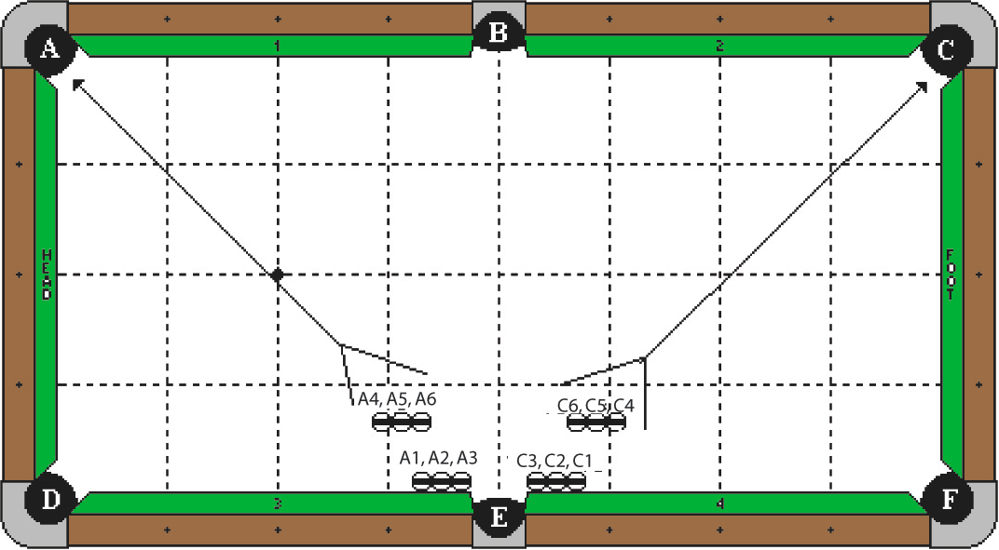

Cue Ball(s) Placement:

Not applicable

Object Ball(s) Placement:

“A1”, “A2”, and “A3” balls are frozen in line and to the cushion, with the edge of the “A3” ball aligned with the pocket point. The “A6” ball is 2 ball’s width away from the “A1” ball and straight out. The “A4” and “A5” balls are frozen in line with the “A6” ball as diagrammed, and parallel to the cushion. Balls “C1” through “C6” form the mirror image of balls “A1” through “A6”.

Objective:

Jump the “A1”, “A2”, and “A3” balls in numerical order into pocket ‘A’. Then shoot the “A4”, “A5”, and “A6” balls in numerical order into pocket “A”. Perform the same shots with the mirror image balls, making them in numerical order in pocket “C”.

Special Notes: No balls may be disturbed in any manner during the process of shooting any designated ball.

Scoring:

- Attempt #1 – 8 points
- Attempt #2 – 7 points
- Attempt #3 – 6 points

DISCIPLINE
8

MASSE
SHOTS

Discipline: Masse Shots Shot / Challenge #1

Degree of Difficulty: 4.0

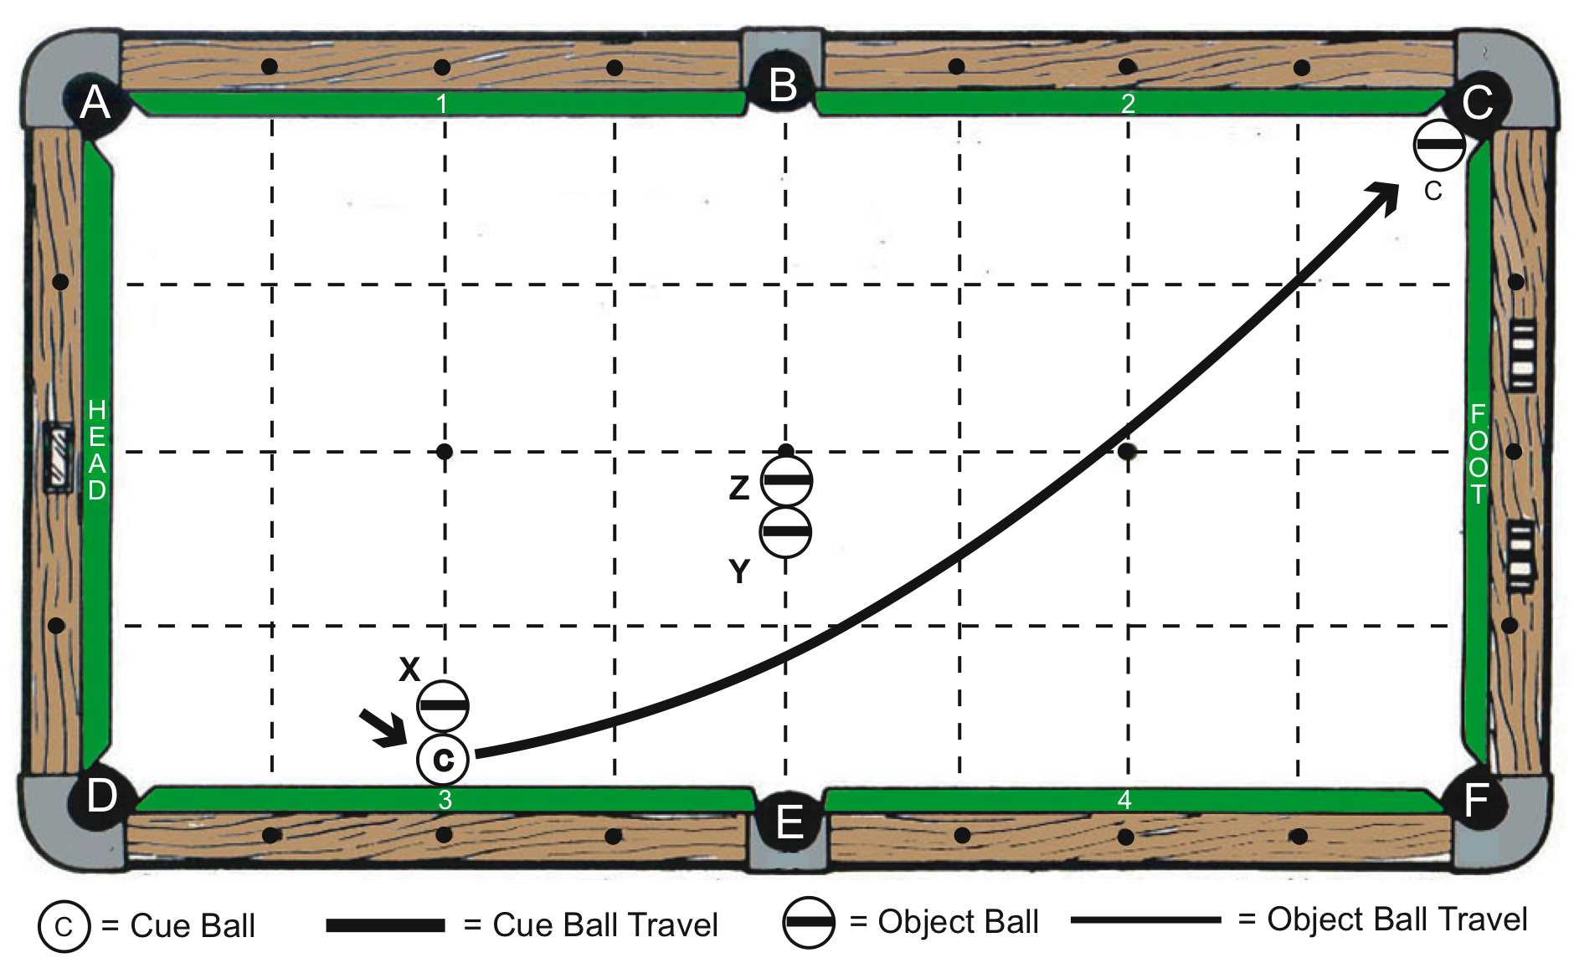

Cue Ball(s) Placement:

Frozen to cushion #3 and at center diamond between pockets “D” and “E”
Object Ball(s) Placement:

“X” ball is frozen to cue ball and straight in line with it perpendicular to cushion #3; “Z” ball is on center line (B – E) with edge closer to pocket “B” even with long center line of table; “Y” ball is frozen to “Z” ball and straight in line with it on center line (B – E). “C” ball is centered in “C” pocket with back edge of ball flush to edge of slate.
Objective:

Shoot cue ball into cushion #3, causing it to “escape” from behind “X” ball and “level masse” or curve around “Y” and “Z” balls, finally making “C” ball in “C” pocket.
Special Notes:

Cue ball may contact extra cushion by “C” ball before making it. “X”, “Y”, and “Z” balls may not move from their original positions until after make of “C” ball is complete.

Scoring:

- Attempt #1 – 4 points
- Attempt #2 – 3 points
- Attempt #3 – 2 points

Discipline: Masse Shots Shot / Challenge #2

Degree of Difficulty: 5.0

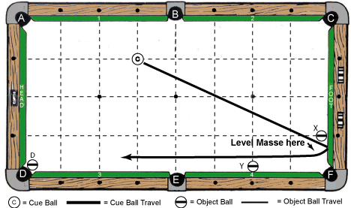

Cue Ball(s) Placement:

Centered on long table line 1 segment from cushion #1 and 1 segment to left of B – E line

Object Ball(s) Placement:

“X” ball is frozen to foot cushion and centered at 1 diamond from pocket “F”, “Y” ball is frozen to cushion #4 and centered on foot string line, “D” ball is at or near pocket “D”

Objective:

Shoot cue ball to foot cushion between “X” ball and pocket “F”. The cue ball will “level masse” past “Y” ball to make “D” ball in pocket “D”.

Special Notes: “X” and “Y” balls may not move until after shot is complete

Scoring:

- Attempt #1 – 5 points
- Attempt #2 – 4 points
- Attempt #3 – 3 points

Discipline: Masse Shots Shot / Challenge #3

Degree of Difficulty: 6.0

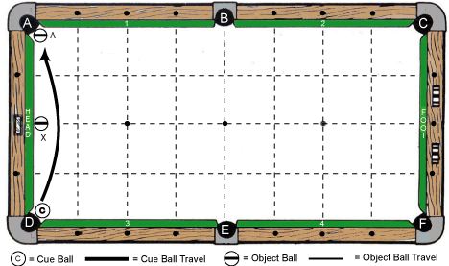

Cue Ball(s) Placement:

Centered in pocket “D” with back vertical edge even with slate cut

Object Ball(s) Placement:

“A” ball centered in pocket “A” with back vertical edge even with slate cut, “X” ball frozen to head cushion and centered on middle diamond or long center table line

Objective:

Shoot cue ball with half masse stroke around “X” ball and make “A” ball in pocket “A”

Special Notes: “X” ball may not move until after shot is complete

Scoring:

- Attempt #1 – 6 points
- Attempt #2 – 5 points
- Attempt #3 – 4 points

Discipline: Masse Shots Shot / Challenge #4A

Degree of Difficulty: 7.0

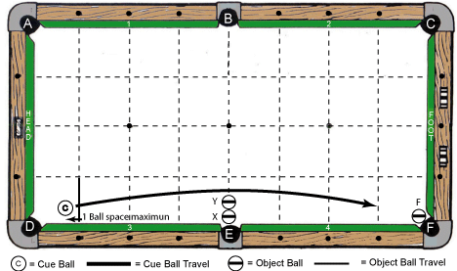

Cue Ball(s) Placement:

In hand – anywhere behind dark line 1 diamond segment to right of pocket D, but no more than 1 ball spacing distance off cushion #3

Object Ball(s) Placement:

“X” ball is centered on B – E line with back vertical edge even with slate cut, “Y” ball is frozen to “X” ball and also centered on B – E line, “F” ball is centered in pocket “F” with back vertical edge even with slate cut

Objective:

Shoot cue ball with half masse stroke around “Y” ball and make “F” ball in pocket “F”

Special Notes: “X” and “Y” balls may not move until after shot is complete

Scoring:

- Attempt #1 – 7 points
- Attempt #2 – 6 points
- Attempt #3 – 5 points

Discipline: Masse Shots Shot / Challenge #4B

Degree of Difficulty: 7.0

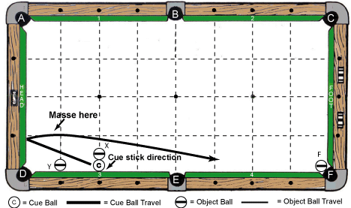

Cue Ball(s) Placement:

Frozen to cushion #3 and centered on head string line

Object Ball(s) Placement:

“X” ball frozen to cue ball and centered on head string line, “Y” ball frozen to cushion #3 and centered at 1 diamond to right of pocket “D”, “F” ball is at or near pocket “F”

Objective:

Shoot cue ball into cushion #3 with half masse stroke. Cue ball will compress cushion and “escape” to rebound off head cushion with “masse” action around “X” ball. Then, cue ball will make “F” ball in pocket “F”.

Special Notes: “X” and “Y” balls may not move by any means until after shot is complete

Scoring:

- Attempt #1 – 7 points
- Attempt #2 – 6 points
- Attempt #3 – 5 points

Discipline: Masse Shots Shot / Challenge #5A

Degree of Difficulty: 8.0

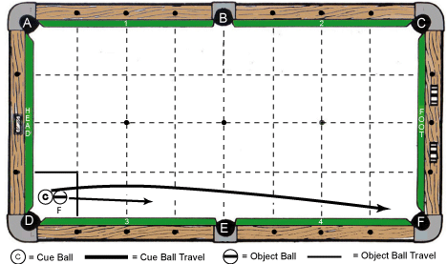
Cue Ball(s) Placement:

In hand – anywhere in marked box zone near pocket “D”

Object Ball(s) Placement:

“F” ball frozen to cue ball – anywhere in marked box zone near pocket “D”

Objective:

Shoot cue ball into “F” ball with half masse stroke. Cue ball will go around “F” ball as it travels down table toward pocket “F”. Cue ball and “F” ball make in pocket “F”. Cue ball goes in first.

Special Notes: Multiple hits are allowed between cue ball and “F” ball on way to pocket “F”.

Scoring:

- Attempt #1 – 8 points
- Attempt #2 – 7 points
- Attempt #3 – 6 points

Discipline: Masse Shots Shot / Challenge #5B

Degree of Difficulty: 8.0

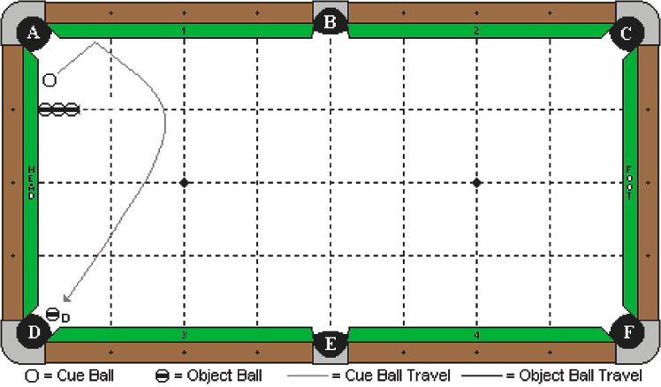

Cue Ball(s) Placement:

In hand between line of 3 balls and cushion #1 and no more than 1 ball’s width off head cushion

Object Ball(s) Placement:

3 blocker balls are frozen straight in line and centered on the 1st diamond long table line as diagrammed. The first ball is frozen to the head cushion. “D” ball is centered between points of pocket “D” with the back edge of the “D” ball flush with the edge of slate.

Objective:

Shoot the cue ball into cushion #1 as diagrammed. Cue ball will then “reverse masse” around the 3 blocking balls to make “D” ball in pocket “D”.

Special Notes:

The blocker balls may not be touched by any means until after “D’ ball is made. The cue ball may not contact the foot cushion until after “D” ball is made.

Scoring:

- Attempt #1 – 8 points
- Attempt #2 – 7 points
- Attempt #3 – 6 points

TIEBREAKER
CHALLENGE

# 1

Shot / Challenge (1st Tiebreaker) – Discipline: Stroke Shots

Special Scoring: Cumulative Total for 3 Rolls (6 / 8 / 10)

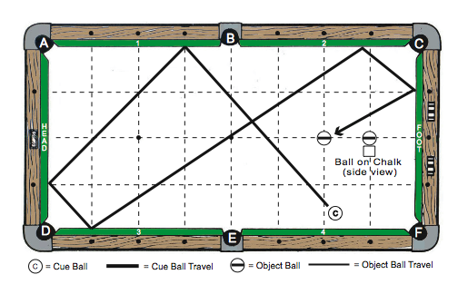

Cue Ball(s) Placement:

In hand – anywhere behind line (B – E)
Object Ball(s) Placement:

Any object ball is placed on top of a chalk cube on foot spot of table
Objective:

Shoot cue ball 5 cushions as diagram indicates. 6 points awarded if cue ball finishes within 1 ball’s width of object ball on chalk. 8 points awarded if cue ball hits object ball on chalk without freezing and ball stays on top of chalk. 10 points awarded if cue ball freezes to ball on top of chalk. 3 rolls are granted and cumulative total for all 3 counts for score.
Special Notes:

New piece of chalk must be used for this shot / challenge

Scoring:

- 3 Attempts – Cumulative total scored (30 points maximum – See “objective” above)

TIEBREAKER
CHALLENGE

# 2

Shot / Challenge (2nd Tiebreaker) – Discipline: Stroke Shots

Special Scoring: Cumulative Total for 3 Rolls (6 / 8 / 10)

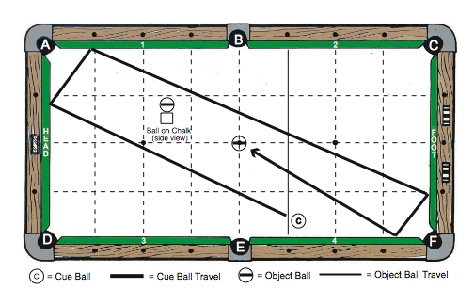
Cue Ball(s) Placement:

In hand – anywhere behind a line formed by connecting one diamond right of pocket “B” to one diamond right of pocket “E”
Object Ball(s) Placement:

Any object ball is placed on top of a chalk cube on center spot of table.
Objective:

Shoot cue ball 4 cushions as diagram indicates. 6 points awarded if cue ball finishes within 1 ball’s width of object ball on chalk. 8 points awarded if cue ball hits object ball on chalk without freezing and ball stays on top of chalk. 10 points awarded if cue ball freezes to ball on top of chalk. 3 rolls are granted and cumulative total for all 3 counts for score.
Special Notes:

New piece of chalk must be used for this shot / challenge

Scoring:

- 3 Attempts – Cumulative total scored (30 points maximum – See “objective” above)

A GIFT FOR YOU!!

Please use this form for shot / challenge submissions, which will be considered for future Artistic Pool Tour Master Program updates/releases

Discipline:

Shot / Challenge #:

Degree of Difficulty:
Cue Ball Placement:
Object Ball(s) Placement:

Objective:
Special Notes:
Scoring Potential

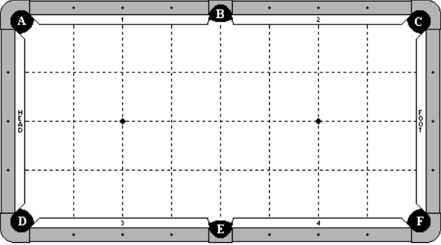

PLAYER AUTOGRAPHS / SPECIAL MESSAGES



